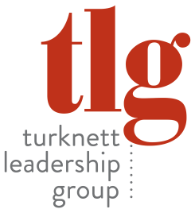
Highlights: Women in Leadership – April 27, 2017
“Football & Family, Author & Nonprofit Leader: Reflections on a Full Life”
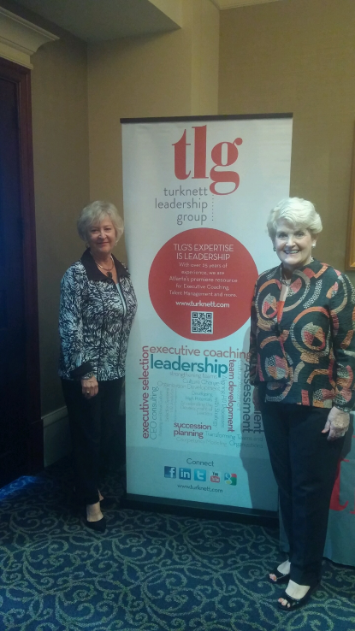
Carolyn Newton Curry, PhD and Founder / Director of Women Alone Together
In her opening remarks, Dr. Curry (Carolyn) acknowledged that she feels truly blessed to have had – and still have – a very full life. And, as she shared her story with the audience, they too felt blessed and inspired by this incredibly smart, charming, and vivacious leader / historian. They also came to appreciate a primary message she shared: “Life comes in ‘fits and starts’ especially for women. It doesn’t typically go in a straight line.”
Carolyn’s personal ‘fits and starts’ story began in College Park, GA where she described her life as “simple but good – all about family, church, and school.” Her immediate family consisted of her mother and father - both strong role models - and a younger brother. Another very influential person in her formative years was her maternal grandmother, a woman who chose to move from the farm to “the city” in order to pursue her dream of teaching piano.
(Key lesson #1) Reflecting on the strong women in her background, Carolyn said, “It’s our responsibility to be strong women and to encourage others along the way.”
While Carolyn was growing up, she met a boy in the 4th grade named Bill Curry. A number of years later at 17, she had her first date with this young man who just happened to be a pretty good high school football player. For Carolyn’s birthday, her mom planned a big party and had a cake in the form of a football field. Who knew that a few years later – at the age of 20 - Carolyn would become “Mrs. Bill Curry” and her life would never be the same!
But before that part of her life began, there was another woman who influenced Carolyn significantly – her Spanish teacher, Dr. Miriam Felder, an Agnes Scott College alumna. She persuaded Carolyn to reconsider her thoughts of a home economics major to a more intellectually challenging path – at Agnes Scott.
(Key Lessons #2) “In the 60’s,” Carolyn said, “Agnes Scott was a pioneer in having a lot of female professors – especially PhD’s – all great teachers who helped her gain confidence and raise her aspirations.”
While she was still in college and Bill was attending Georgia Tech and playing football there, the two sweethearts were married. Neither had any idea of the journey ahead, or the unconventional life that they would have. They could only dream of a future that would include a daughter and a son, seven grandchildren, and a 55th wedding anniversary to be celebrated in December of 2017!
Bill was drafted by the Green Bay Packers in 1963 while still at Georgia Tech – only finding out after Carolyn’s brother called him after reading about it in the paper! Carolyn said, “This was the start of what could be called a pretty disjointed, crazy and complicated family life. Four NFL teams, multiple college head coaching positions (Georgia Tech, Alabama, and Kentucky plus creating the football program at Georgia State) - back and forth to Atlanta in the off season with our two children – that was our life for many years.”
(Key lesson #3) “People ask if it was difficult. Well, in life you do what you have to do.”
Later there came a time when Carolyn said, “Back at Georgia Tech when Bill was coaching there, I began experiencing a ‘longing’ to find / retrieve my own identity. Having been ‘sucked up’ in the macho world of sports, I questioned what I wanted to do with my life and thus I started a conscious search for my true passion.”
(Key lesson #4) “As a woman you must save a part of your life for yourself.”
Carolyn called the 70’s the “decade of women” and that was when she decided to pursue her passion for women’s history – especially after discovering how little of it had actually been recorded. Every paper she wrote – and there were many – was about a woman, almost always about those no one had ever heard of (e.g., Frances Wright.) When Carolyn entered her doctoral program, she knew there would be 3-4 years of work and papers, so she chose biographies – specifically of Georgia women in the past. Little was known about these women because of the cult of domesticity and the dominant male culture. Therefore Carolyn realized that she’d have to find private sources for her research.
Soon Carolyn’s world was transformed when at Duke University she found the personal diaries of a 19th century heroine named Ella Gertrude Clanton Thomas. This incredible Georgia woman’s life would become a second life for Carolyn and the subject of her dissertation as well as the title of her first book published in 2015 (Suffer and Grow Strong: The Life of Ella Gertrude Clanton Thomas 1834-1907.)
Studying the 40 years of Mrs. Thomas’ diaries, Carolyn discovered many things about women of this era, e.g., the fact that women did not even have guardianship rights over their own children! But she also discovered the many contributions of this particular woman including the women’s suffrage movement. “In 1899,” Carolyn said, “Ella Gertrude became president of the embryonic Georgia Woman Suffrage Association for the first time they met in convention.”
(Key lesson #5) Carolyn came to see very clearly that - “Over time, women’s progress has been transformed by their suffering – helping them grow in strength and resilience.”
Carolyn went on to explain that this particular lesson was one of the main reasons she started her nonprofit organization, Women Alone Together. “While teaching a college class in Kentucky, I had a student, a 78 year old woman who was alone in her life, and was truly eager to learn. And - she wasn’t by herself! There were so many others, almost like ‘groupies,’ who were reinventing their lives after suffering a loss of some kind. Whether it was a trip around the world on a freighter, or some other pursuit, these women were going for it - all the while, inspiring and supporting each other. One woman wore three gold bands – one for her early life; one for her married life before her husband died; and the 3rd for her ‘new life’ after the loss.”
Given the large number of women in our society who fit the profile of a woman who is by herself for one reason or another, Women Alone Together (W.A.T.) has continued to grow in its outreach and impact. W.A.T. provides multiple programs including seminars, a book club, and various opportunities for support, confidence building and community engagement. “We laugh a lot, we learn, and we share wisdom,” Carolyn said.
(Key lesson #6) “It’s good to reflect over one’s life. In my case, I think you can see how the different parts of my life have come together. My passion for women past and present continues and I believe women can make an important contribution at any time / any stage of their lives.”
A few other “key lessons” from Carolyn:
- Make your own identity a priority
- The value of history to inform and inspire us
- Deliberately search for the thing that you’re most passionate about and build a career
- Be careful who you choose to marry or as your life partner
- When you’re happy, you look and feel better!

