October 27, 2017
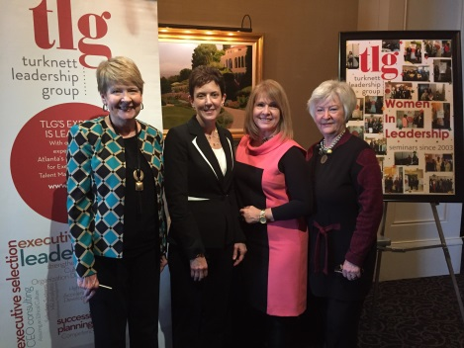
Women in Leadership Highlights

Christine Hurtsellers, CEO – Voya Investment Management
For TLG’s 173rd WIL seminar, we were fortunate to have a highly respected businesswoman, Christine Hurtsellers. Recently honored by the ATL Business Chronicle at their annual Women Who Mean Business Awards, Christine is often described as extremely smart and equally caring. Everyone who knows her, and those in attendance at WIL, would certainly agree!
Christine began her remarks by sharing four distinguishing characteristics that she believes make a leader particularly special. They are:
- Authenticity
- Making people feel important, being there “in the moment”
- Being there when it counts
- Having faith / showing faith
Christine went on to discuss these characteristics and related them to her own experience - in both her personal and professional journey. She talked about a very challenging time during the financial crisis - a time that was like “walking into the furnace.” It became her time - actually her calling - to step up into a much needed leadership role – and over time - to step-by-step rebuild confidence among clients, team members and colleagues.
As a leader, Christine showed her authenticity by being genuine, transparent, and by communicating consistently and frequently through skip level meetings. While she said she sometimes felt overwhelmed, she nevertheless continued to spread hope – a belief in a better tomorrow - and tried to “just do the right thing” in every situation and with every decision.
In another very authentic example, Christine relayed a situation in which she became defensive with a colleague – a type of behavior her organization referred to as “below the line” behavior. Taking responsibility for her actions, she said: “I apologized to the person because I knew I was wrong.”
Next, Christine shared several ways in which leaders can make people around them feel important, being “in the moment.” Listening – really listening – is certainly one way to show people that you care about them – about their success, and about their development.
Another important differentiator of good leadership is “being there when it counts – when it matters.” Even the way in which you handle letting someone go shows your character and makes a difference to the person. Providing coaching, showing respect, and demonstrating and supporting volunteerism are all ways to show that people matter to you.
Christine is clearly proud of her firm’s commitment to community volunteerism as well as the fact that they’ve received a “best place to work” award twice. “People who work at Voya have described the culture as being like a family,” she said, “I think that’s true.” During a serious health issue, she herself was on the receiving end of the firm’s and her team’s caring nature as they supported her through an extremely difficult and sometimes dark time.
Faith is yet another factor that distinguishes good leaders, according to Christine.
“To me, it’s about having faith in one’s self and in others; having hope; giving people a vision; having passion; and overcoming the NO’s,” said Christine.
Clearly, Christine has overcome many personal and professional obstacles and has risen to the top of her game in an industry where women represent only 2% of CEOs in asset management. However, she’s proud of Voya for having a significant number of women on their board and in top level positions. She’s also very proud of taking her organization from last to “best in class.” Not bad for a small town Indiana girl without any Ivy League credentials!
Other major take-aways from Christine:
“Accountability – asking the Who, What, & When – Consistency and values-based communication is a major way to encourage your team to attain goals that may seem impossible.”
“Be a consultant, not an auditor.”
“Strategic thinking is a gift.”
“Enjoy the gift of an ordinary day.”
“Just do the next right thing to get through the day”
“I think being the mother of 5 boys actually accelerated my career and helped me as a team leader.”

